Find – we find the file based on criteria search any directory

Find –type f – finds only file without directory

Find –type d – directories

Touch- used to create a file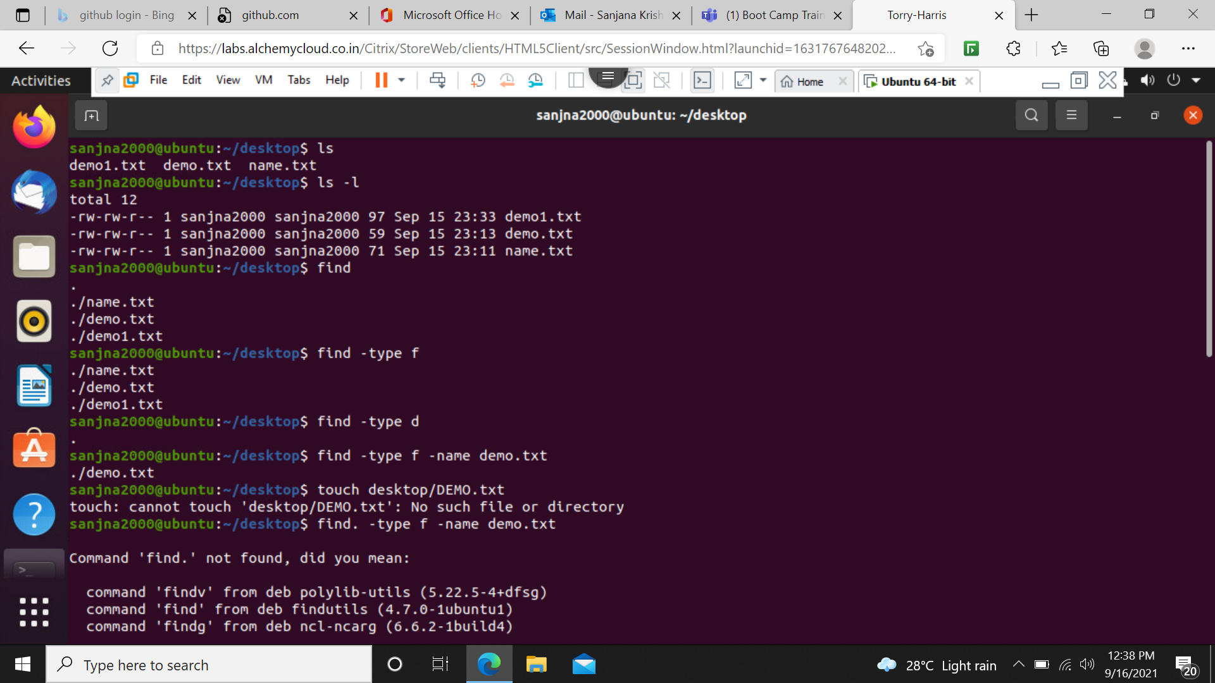

Find . -type f –name filename – search the file (case sensitive)

Find . -type f –iname filename – shows everything irrespective of case

Find . -type f –iname d\* - search the file which begin with d(not case sensitive)

Find . -type f –perm 0777 –exec chmod 555 {} \;– change the permission

Find . -mtime –1 – shows file which was modified in 1 hour

Find . -mtime +1 – less than an hour

Find . -mmin –1 – more than 1 min

Find . -mmin +1 – less than 1 min

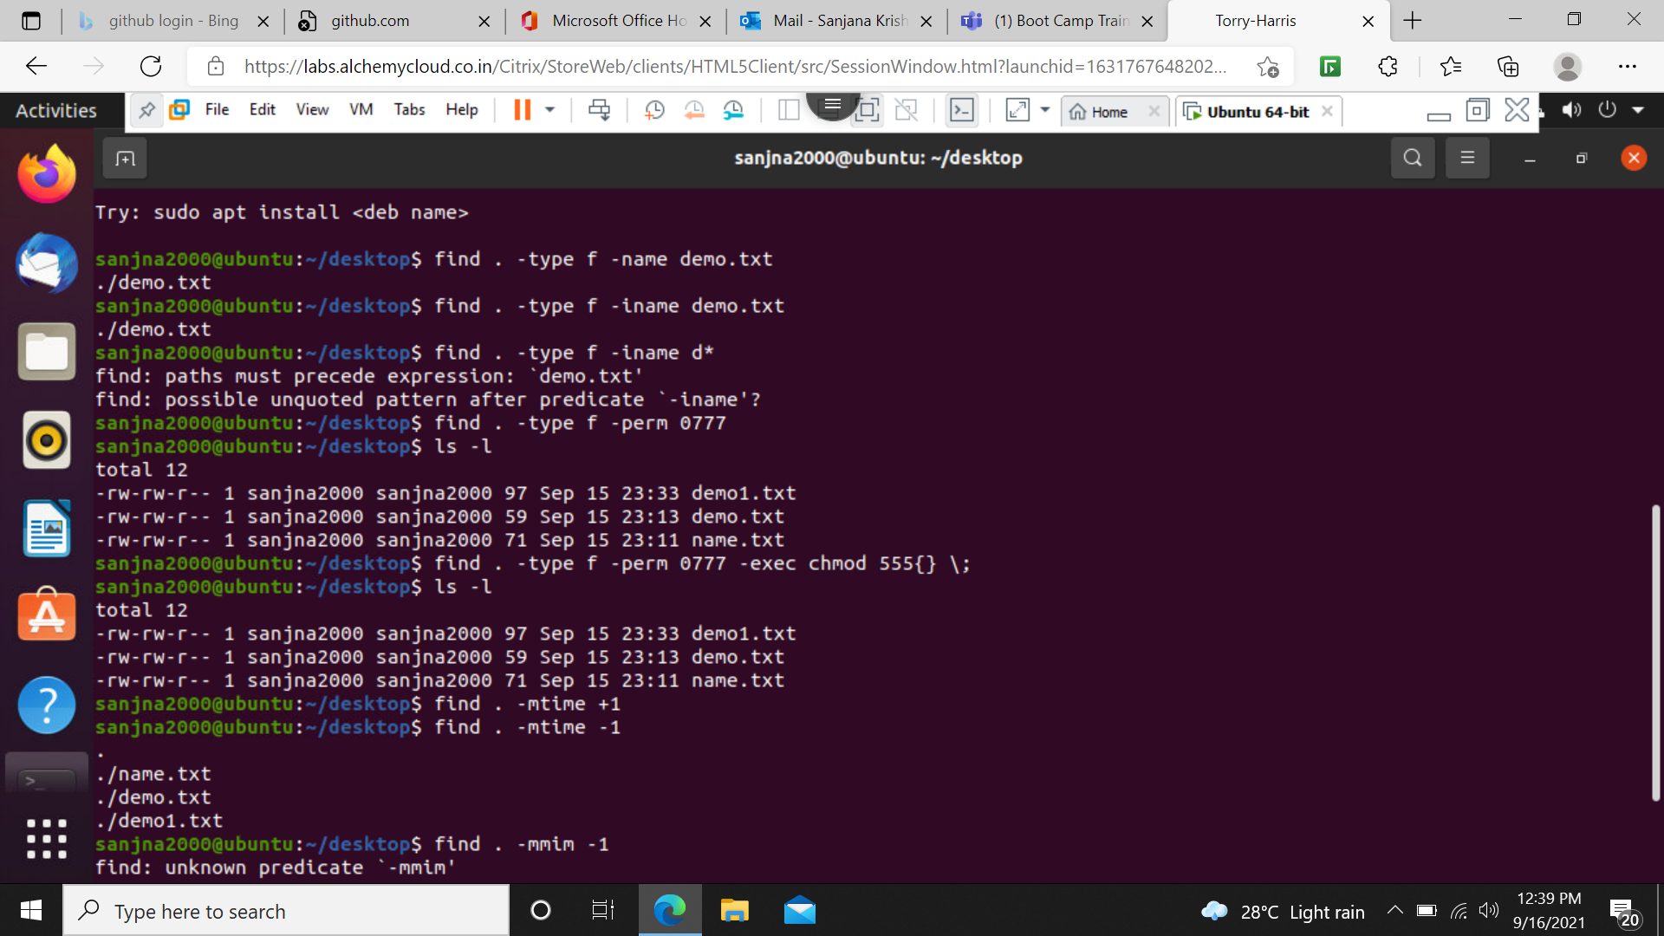

Find ./ –name filename –exec rm {} \; - without confirmation

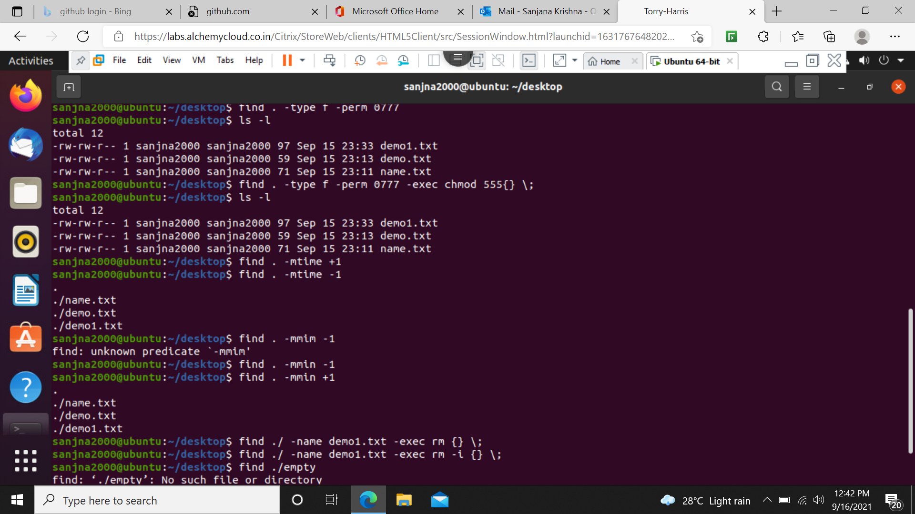

Find . -type f –name “\*.txt” -exec grep ‘in’ {} \; - search the file which has in

Find . -type f –name “d\*1\*” - d (can be anything) 1 (can be anything)

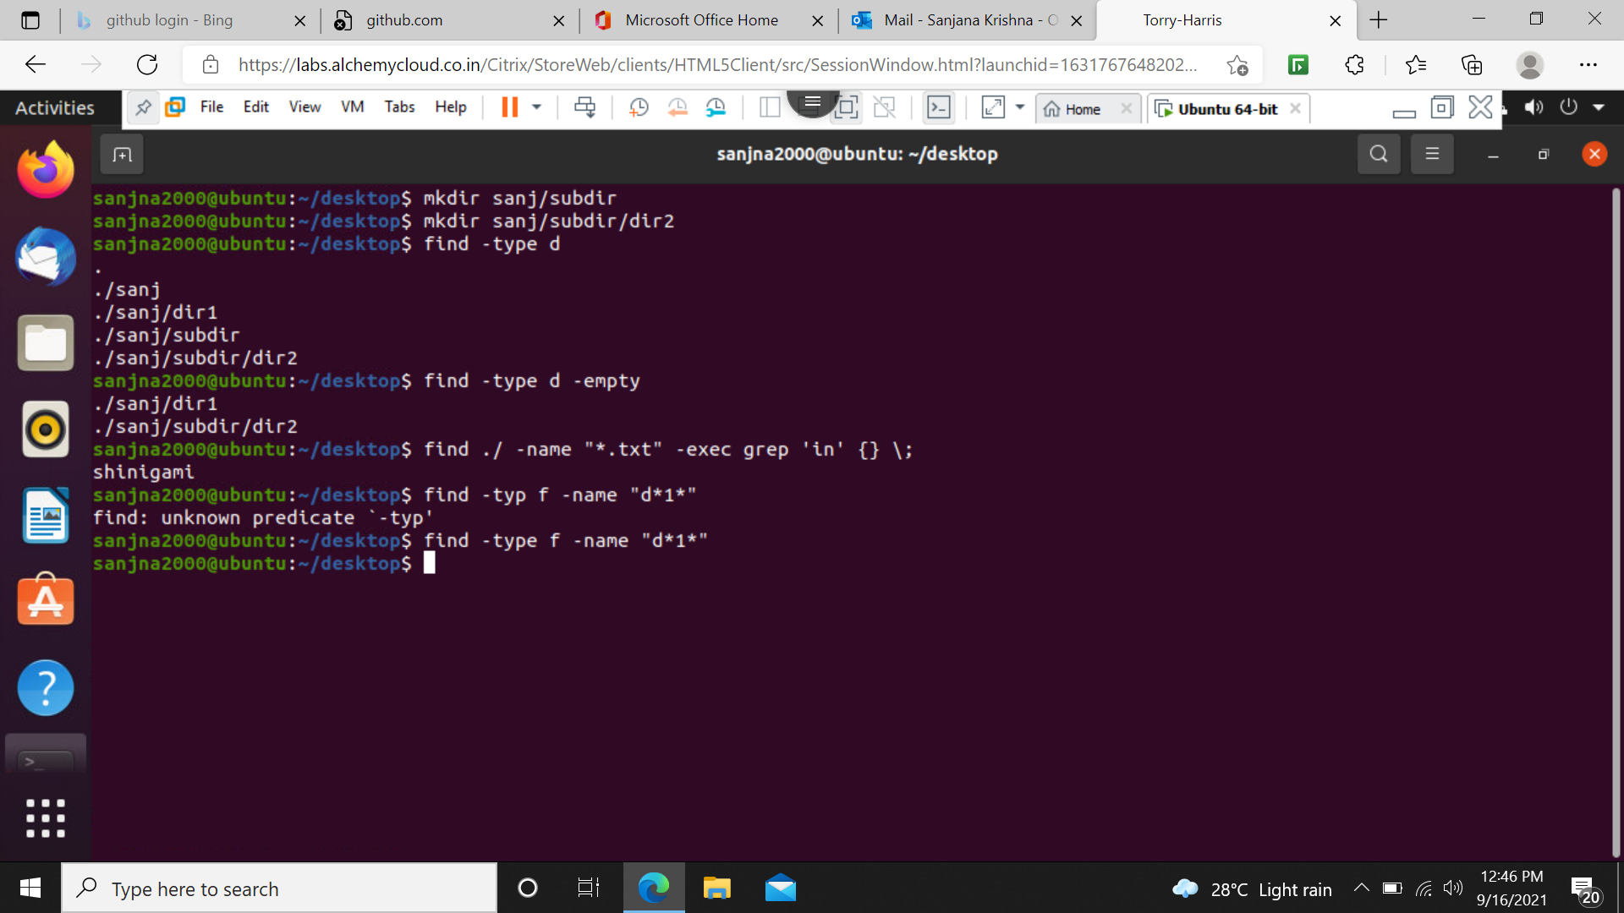

Bash – unique shell & command language or interpreter

Filename.sh - extension for shell

./filename - runs the command

Scripting for printing the word hello

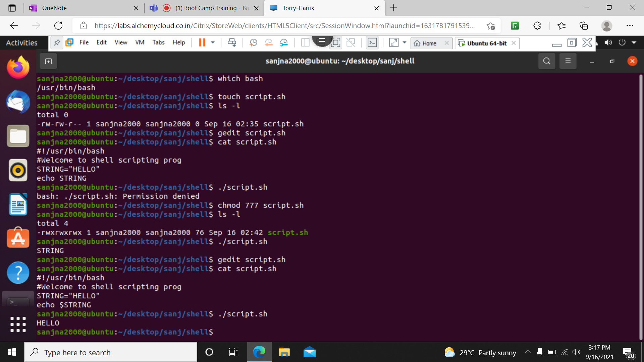

Scripting for adding two numbers

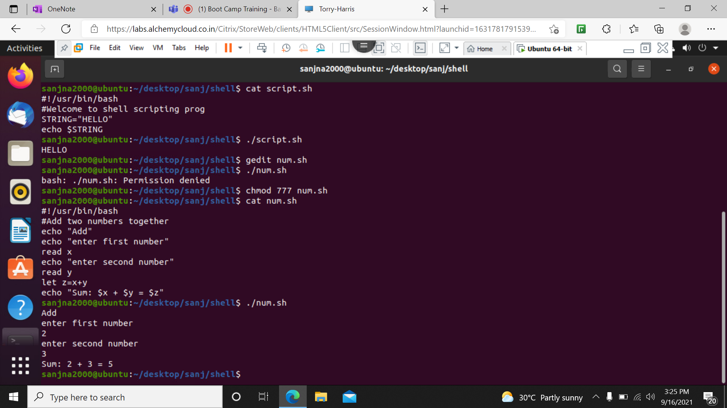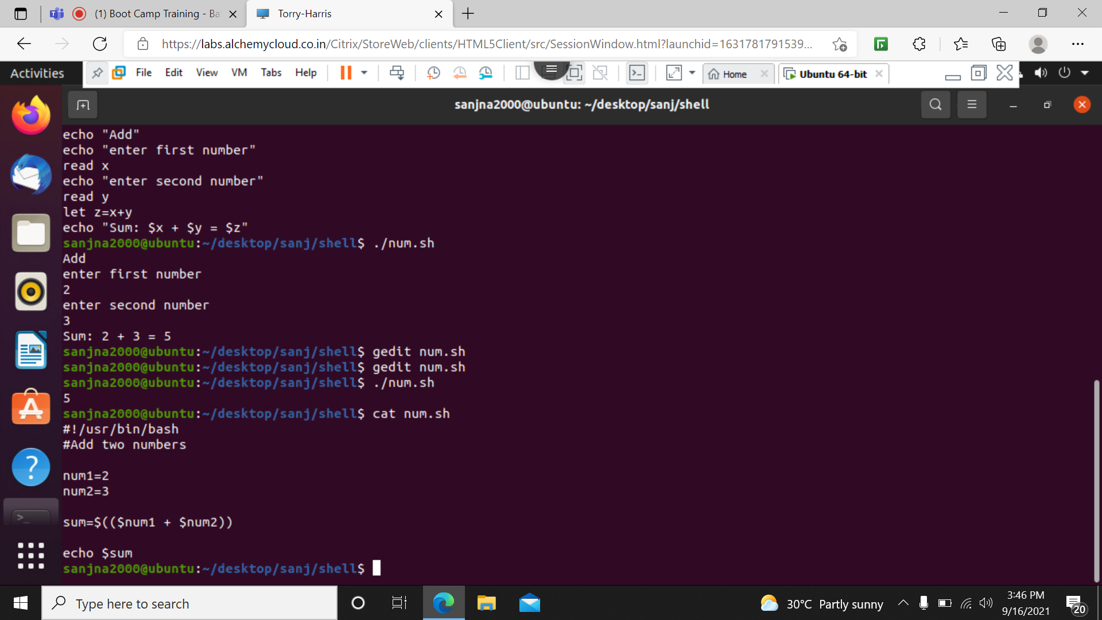

Scripting to concatenate two strings

